

|  |  |  |  |  |  |  |  |  |
| --- | --- | --- | --- | --- | --- | --- | --- | --- |
|  | | | | | | | | |
|  | | LIBRARY MANAGEMENT SYSTEM | | | | |  | |
|  |  | | | | | | |  |
|  | | | |  |  | | | |
|  | | | | Beenish Ali (21K-3865)Baneen Fatima (21K-3833)Muniba Majid (21K-3806) |  | | | |
|  | | | | 7TH DEC 23—Database—Miss Abeer Gauher |  | | | |
|  | | |  | | |  | | |



|  |  |  |  |  |  |  |  |  |
| --- | --- | --- | --- | --- | --- | --- | --- | --- |
|  |  | | |  |  | | |  |
|  | INSTRUCTIONS | | | | | | |  |
|  |  | | |  |  | | |  |
|  |  | |  | | |  | |  |
|  |  |  | The Library Management System (LMS) is a comprehensive software application designed to streamline and enhance the operations of a library, facilitating efficient management of books, users, and related activities. This system employs a combination of modern technologies, including swing for the frontend desktop application, and Oracle as the relational database management system. | | |  |  |  |
|  | | | | |
|  |  |  |  |
|  |  |

**Features**

In this library management system, users, both administrators and students, can seamlessly navigate through a range of essential functionalities. Administrators possess the capability to manage the extensive book catalog, enabling them to add, update, and remove books from the system. The database is meticulously designed, ensuring efficient storage and retrieval of information through normalized tables and well-defined relationships.

For students, the system allows them to peruse the available book collection and, if interested, reserve books for future borrowing.

One distinctive feature is the capability to identify defaulters – students with overdue books. The system generates a defaulter list, ensuring administrators can promptly address any issues related to overdue returns. Additionally, the platform incorporates a feedback mechanism, allowing users to share their insights and experiences regarding the books they have borrowed. This feedback loop enhances the overall user experience and aids in making informed decisions about book selections.

The user interface is intuitively designed for ease of navigation, with search and filter functionalities facilitating quick access to specific books. The system also prioritizes security, employing measures such as user authentication and authorization to safeguard sensitive information.

**SQL Concepts**

In the development of the library management system, several key SQL concepts have been effectively utilized to enhance the functionality and efficiency of the database. The incorporation of SQL joins has facilitated the establishment of relationships between different tables, such as connecting the "Books" table with the "Transactions" table through INNER JOINs to retrieve information on issued and returned books.

Triggers have been employed to automate actions based on specific events, streamlining processes within the system. For instance, triggers have been implemented to automatically update the availability status of a book in the "Books" table when a new transaction is recorded in the "Transactions" table, ensuring real-time synchronization of data.

Additionally, stored procedures have been employed to encapsulate and execute sets of SQL statements, promoting code reusability and simplifying complex operations. Procedures have been created for various functionalities, such as issuing books and generating defaulter lists, contributing to the overall maintainability and scalability of the system.

These SQL concepts collectively contribute to the robustness and effectiveness of the library management system, enabling seamless data management, automation of routine tasks, and efficient execution of complex operations. The utilization of joins, triggers, and procedures underscores a thoughtful and comprehensive approach to database design and functionality.

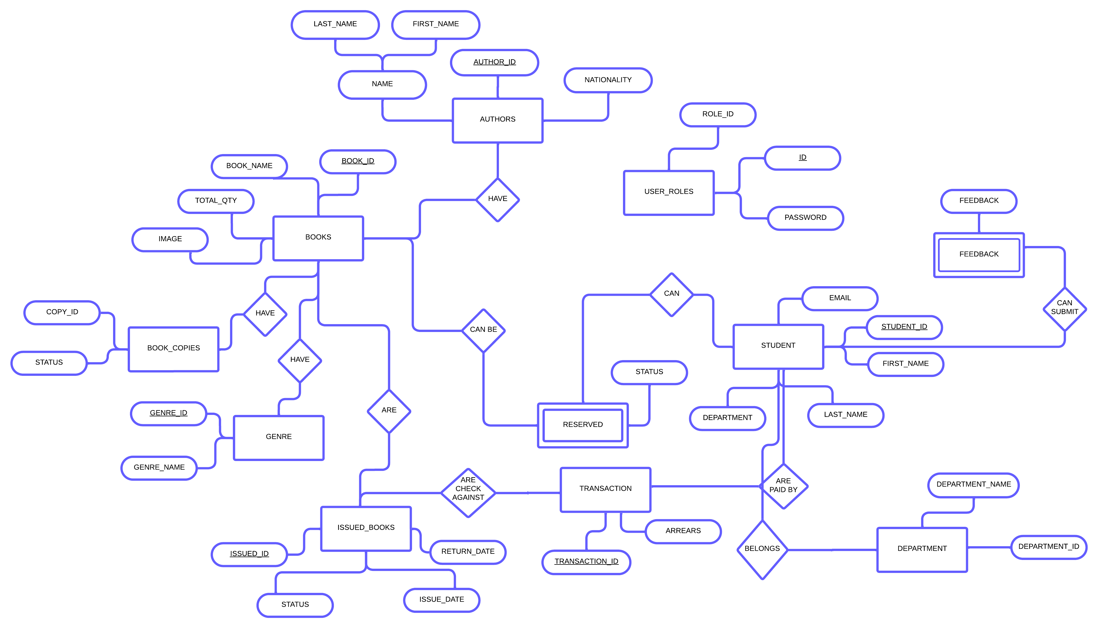**ER Diagram**

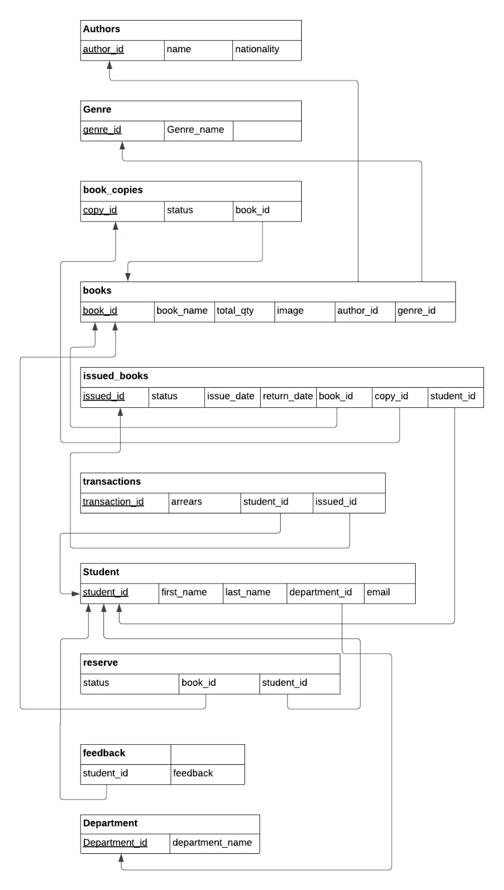

**Schema**